MANUSCRIPTS FORMAT FOR THE SYMPOSIUM OF METROLOGY 2020 (Arial 14-point)

Name Author A, Name Author B, Name Author C (Arial 10-point)
Author’s Institution
Address
Telephone and e-mail

Abstract: The abstract should not exceed 100 words, and must be written using the justified option Arial 10-point font.

1. INTRODUCTION

This format is intended for standardization of the typescripts that are to be presented at the Symposium of Metrology 2020. All papers will be gathered, reviewed by the Technical Committee and then be published at the Symposium Proceedings. We deeply appreciate your contribution.

The maximum length of the paper is 6 pages, including figures and references. This section, as well as sections 2 to 4, and “References” section described next are strongly recommendable for being included. In “Introduction” section the purpose, the background and the importance of the paper are described.

Papers should be own authored or, if it is necessary to include a third party, it has to be properly pointed out in the text of the paper and referred as indicated in “References” section.

2. THE BODY OF THE PAPER (EXPERIMENTAL DETAILS, MATH MODELS …)

In this part a full description of the procedures, experimental details, hypothesis and mathematical model could be presented. This part may include several sections, all having specific titles and sequentially numbered in accordance with the content.

3. RESULTS

Each section can be organized in sub-sections, numbered as follows:

3.1. Results A

3.2. Results B

In "Results” section, the effects or deductions arising from the developing of section 2 should be presented.

4. DISCUSSION

The “Discussion” section is used to highlight the advantages, disadvantages and salient details that would give rise in the intention, application and results described in the preceding sections.

5. CONCLUSIONS

In “Conclusions” section is described the scope of the intention of the work and achievements.

ACKNOWLEDGEMENTS

If applicable, this section should not be numbered.

REFERENCES

The references should be numbered sequentially in square brackets, and listed in numerical order at the end of the paper. Please see the following examples:

[1] A. B. Author, Title of Book. New: IEEE Press, Ch. 6, pp. 23-25, 1992.
[2] C. D. Author, “Title of Paper,” in Proc. of IEEE, vol. 35, pp. 12-19, 1993.
[3] E. F Author, “Title of the Paper”, http://www.xxx.xxx, Date of consulting.

FORMATS

The typescript should be written using Microsoft Word, version 2003 or newer, letter sheet size, double-column format (with the exception of the title and abstract), full justification in Arial 10-point font.

Margins: top 3.0 cm, bottom 2.5 cm, left and right 2.2 cm, and space between columns 0.7 cm.

The text should be single-spaced. One single space should be inserted between paragraphs, between text and equations, figure’s title and text and between tables and text.

Type the typescript title in capital letters, bold format, Arial 14-point, centered horizontally.

After one line of space, type the author’s names (first name, followed by the last name), Arial 10-point, centered horizontally. In separate lines type information referred to: author’s institution, mailing address, the telephone number and email address (these last two items in the same line).

The main headings have to be typed with bold capital letters, Arial 10-point, and left justification. The secondary headings or sub-sections should be typed using bold type capital and lower case letters, and left justification.

Equations should preferably be edited in Times New Roman 10-point. Number equations have to be written sequentially by Arabic numerals in parentheses to the right –hand side of the column. Use italic format for symbols of quantities. Example:

$V_{\text{mol}}=M_{\text{mol}}⋅\frac{V}{m}$ (1)

Graphs and figures: JPEG format is strongly recommended for figures (BMP format is strongly discouraged). Mention all figures in the text and number them sequentially; incorporate each figure into the document near its citation in the text. All symbols and letters into the figures should be visible, sharp and black. Figures and graphs should be size adjusted to the column width; if necessary they can be adjusted to the page width. In order to prevent any involuntary change in the position of the figures or graphs please make use of the menu “image format”, then select the sub-menu “design” followed by the “in line with text” option. Excel graphs are better inserted by using the option “paste special” and then selecting “Enhanced Metafile”.

Fig. 1. Example of a graph.

All tables should be numbered sequentially and mentioned in the text. Letter size into the tables should be the same as for the normal text Arial 10-point. Incorporate each table into the document near its citation in the text. Please adjust the width of the table to that of the column. If necessary, the table width can be adjusted to page width.

Type the title of figures and tables using italic, Arial 10-point and centered to the corresponding width column. All tables, figures and graphs should be sequentially numbered.

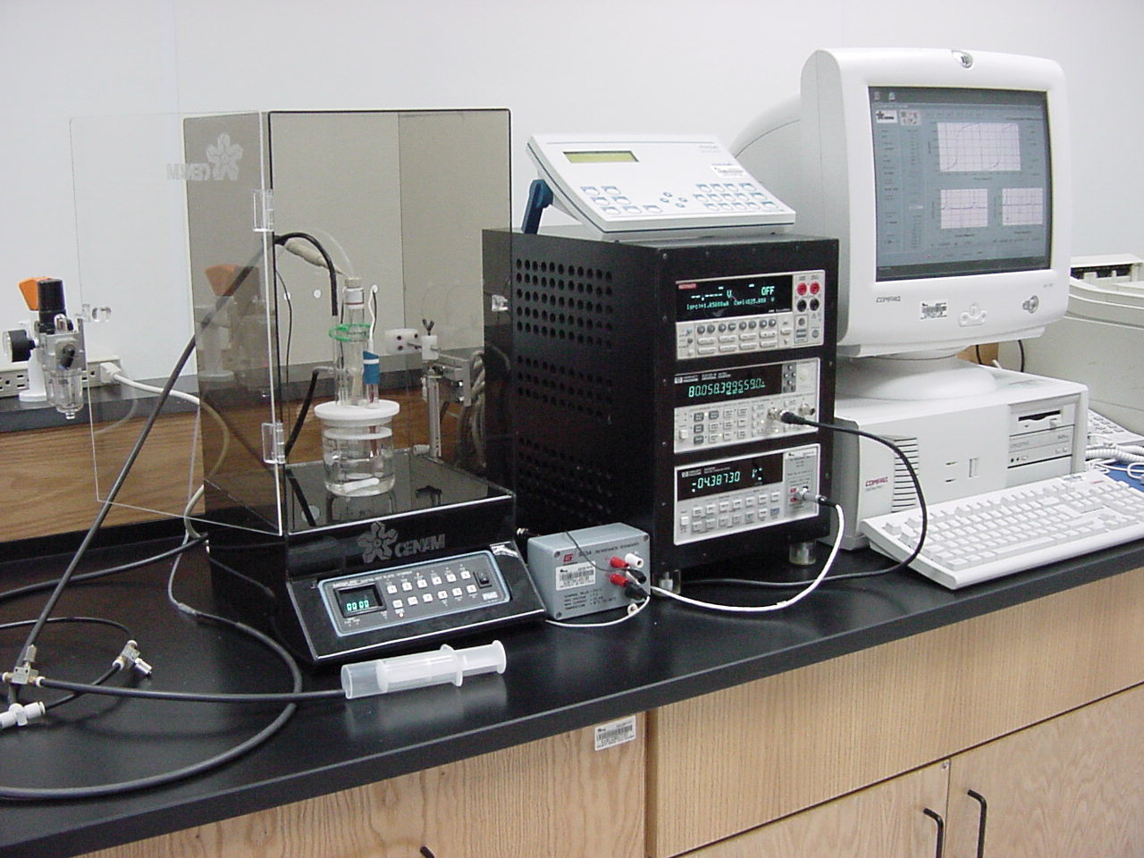
Fig. 2. Example of a graph, adjusted to page width.

E-MAILING

All typescripts, in electronic format, should be uploaded through the website www.cenam.mx/simposio. Any comments about this process please contact us by e-mail to:
autores-simposio@cenam.mx.

